Research Proposal: Optimal Latent Dimensionality in Diffusion Models

1. Problem Statement
Latent diffusion models compress data before running diffusion, reducing computational cost. But how should you choose the latent dimension?
Issue:
• Too small → information bottleneck, can't represent data, poor generation quality
• Too large → sparse embedding, wasted capacity, earlier memorization
Question: What is the optimal d*_latent as a function of dataset size n and intrinsic data dimension d_intrinsic or as a function of density of training points?

2. Background

2.1 The Memorization Paradox
The closed-form optimal score for diffusion models (Gu et al.) only outputs training data. Yet real models generalize. Why?

2.2 Two Time Scales (Bonnaire et al., NeurIPS 2025 Best Paper)
Training dynamics have two critical timescales:
• τ_gen = O(1): When generation quality emerges
• τ_mem = O(n): When memorization begins
Mechanism: The eigenvalue spectrum of the feature correlation matrix splits into two bulks. Large eigenvalues (learned fast) capture shared structure. Small eigenvalues (learned slow) capture individual training points. The gap between bulks scales with n → more data = wider safe training window.
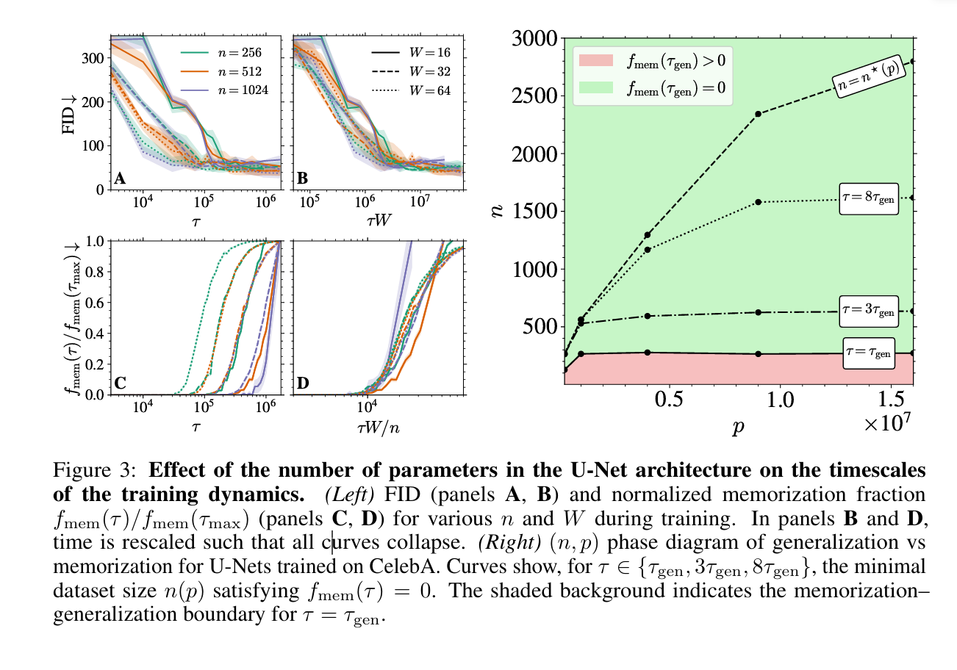

2.3 Geometric Measures of Memorization (yes this is all relevant, probably the most important part)
Core Principle: Memorization as Dimensionality Collapse
From a geometric perspective, memorization manifests as dimensionality collapse in the learned manifold. A well-generalizing model learns a representation whose local dimension matches the intrinsic structure of the data, while a memorizing model collapses regions of the manifold toward point masses corresponding to training examples.
Local Intrinsic Dimension (LID) quantifies the degrees of freedom available to the model at any point x:
- Full generalization: LIDθ(x) ≈ d_intrinsic
- Partial memorization: LIDθ(x) < d_intrinsic
- Full memorization: LIDθ(x) ≈ 0 (point mass)
This connects directly to the eigenvalue framework: large eigenvalues correspond to directions with substantial variance (high LID), while collapse of these eigenvalues corresponds to dimensionality reduction (low LID).

Two Types of Memorization: DD-Mem vs OD-Mem
Ross et al. (2025) formalize a critical distinction using the Manifold Memorization Hypothesis (MMH):
DD-Mem (Data-Driven Memorization): Occurs when LIDθ(x) equals LID*(x) and both are low. The cause is inherent data structure — duplicates, simple images, or unique identifiers in the training set. The model isn't failing; the data itself lacks variation at that point.
OD-Mem (Overfitting-Driven Memorization): Occurs when LIDθ(x) is less than LID*(x). The cause is model failure — insufficient training data, excessive capacity, or premature convergence. The data has rich structure that the model failed to capture.
Why this matters for latent diffusion: When we compress data through an encoder with bottleneck d_latent, we artificially reduce the effective LID* of the post-encoding distribution. Data that was learnable in pixel space (high LID*) becomes sparse in latent space (low LID*). Therefore, memorization induced by insufficient latent dimension is geometrically equivalent to DD-Mem — the "data" (post-encoding) genuinely has low intrinsic dimension, even though this is an artifact of the encoding rather than the original data structure.
This reframing is crucial: we're not detecting model failure (OD-Mem), we're detecting that the latent representation has made the learning problem inherently memorization-prone.

Measuring Model Dimension: LIDθ
FLIPD (Fokker-Planck LID) from Kamkari et al. (2024) is the state-of-the-art method for estimating model LID. It leverages the Fokker-Planck equation governing diffusion dynamics. The core insight is that LID can be recovered from how log-density changes as you add infinitesimal noise to a point.
For a diffusion model with learned score function sθ, FLIPD reduces to computing the divergence of the score function, which can be estimated efficiently via the Hutchinson trace estimator in a single forward pass.
Practical advantages of FLIPD include that it requires only a single forward pass with no ODE solving, it scales to Stable Diffusion making it the first tractable large-scale LID estimator, and it is differentiable which enables gradient-based token attribution for identifying which prompt tokens drive memorization.
The Normal Bundle Method provides an alternative approach by examining the rank of the score Jacobian. At small noise levels, the Jacobian has rank equal to the normal dimension (D minus LID), so LID equals D minus the rank of the score gradient. This method is more expensive, requiring 4d forward passes, but provides complementary geometric information.

Measuring Data Dimension: LID*
Local PCA (LPCA) estimates ground-truth intrinsic dimension from training data. The procedure is straightforward: given a point x, find its k nearest neighbors in the dataset (typically k equals 100), run PCA on those neighbors, and count how many principal components have variance above a threshold.
Why it works: On a d-dimensional manifold, data locally resembles a d-dimensional hyperplane. PCA reveals d directions with substantial variance (on-manifold directions) and D minus d directions with near-zero variance (off-manifold directions).
Limitations include that it requires access to training data, has quadratic complexity in pairwise distances making it infeasible beyond roughly 100k samples, and therefore cannot estimate LID* for Stable Diffusion or LAION-scale datasets.

Binary Memorization Detection: Nearest Neighbor Criterion
For binary classification of memorized versus novel samples, the standard metric is the relative distance ratio introduced by Carlini et al. (2023) and adopted by Gu et al. (2023). This ratio equals the distance from a generated sample to its nearest training neighbor divided by the distance to its second-nearest neighbor.
Interpretation: When the ratio is close to 1, the generated sample lies in a dense region of the training distribution and is likely generalizing. When the ratio is much less than 1, the generated sample is anomalously close to one specific training point relative to its neighborhood, indicating likely memorization.
The threshold criterion flags a sample as memorized if the ratio falls below a threshold (typically around 0.5) and the absolute distance to the nearest neighbor is below some epsilon.
Carlini's extraction attack operationalizes this by generating many samples per prompt, building a similarity graph, and identifying cliques — groups where all samples are mutually similar to each other, indicating collapse to a memorized training point.

Aggregate Quality Metrics and Their Limitations
Fréchet Inception Distance (FID) measures distributional similarity between generated and real samples in Inception-v3 feature space, comparing the means and covariances of the two distributions.
The relationship to memorization is nuanced. Low FID combined with high memorization means samples look realistic but are copies. Low FID alone does not guarantee generalization. Critically, FID is insensitive to rare memorization events due to its averaging nature.
Why FID is insufficient: A model could achieve excellent FID while memorizing 1% of outputs — the aggregate statistics would not reveal this tail behavior. Hence the need for sample-level geometric metrics like LID and nearest-neighbor ratios.

Jacobian-Based Characterization
The denoising network Jacobian (the derivative of the predicted noise with respect to the input) provides rich geometric information. Its rank approximates the intrinsic dimension through the count of non-zero singular values. Its spectral decay indicates manifold smoothness. Local linearity, meaning small variation in the Jacobian across neighboring points, indicates good generalization.
Achilli et al. show that during training, the Jacobian's singular values evolve systematically: high-variance directions (large singular values) are learned first, while low-variance directions (small singular values) are learned later. Memorization occurs when the model starts fitting the smallest singular values — individual sample details rather than shared structure.
Connection to eigenvalue theory: The Jacobian's spectrum relates to the feature correlation matrix eigenvalues from Bonnaire et al. Large Jacobian singular values correspond to the ρ2 bulk (signal), while small Jacobian singular values correspond to the ρ1 bulk (noise and memorization).

Detection Protocol for Our Experiments
Given our focus on latent dimensionality effects, we propose measuring LIDθ via FLIPD on generated samples, LID* via Local PCA on encoded training data in latent space, nearest-neighbor ratios for binary memorization flags, and overall memorization rate as the fraction of generations with ratio below threshold.
The key comparison is LIDθ versus LID* across different d_latent settings.
Hypothesis: When d_latent is less than d_intrinsic, we expect LID* in latent space to approximately equal d_latent because the encoder bottleneck dominates, and LIDθ will track this, resulting in DD-Mem. When d_latent is greater than or equal to d_intrinsic, we expect LID* in latent space to approximately equal d_intrinsic because data structure is preserved, enabling proper generalization.

3. Hypotheses
H1: There exists an optimal d*_latent that maximizes τ_mem − τ_gen.
H2: d*_latent scales with intrinsic dimension: d*_latent ≈ d_intrinsic.
H3: The relevant quantity is ψ = n / d_latent (analogous to Bonnaire's ψ_n = n/d).
H4: Larger d_latent → smaller ψ → smaller eigenvalue gap → earlier memorization.

4. Two Cases

Case 1: Pretrained Encoder (Fixed, High Quality)
Scenario: Encoder trained on a large dataset, frozen. Only diffusion training varies.
Question: Given a good encoder, how does d_latent affect diffusion memorization?
Confounds: Minimal — encoder quality controlled.
Relevance: Fine-tuning Stable Diffusion, choosing compression ratio.

Case 2: New Distribution (Train Everything)
Scenario: Novel domain, must train encoder and diffusion from scratch on same data.
Question: How do d_latent, n, and encoder quality interact?
Confounds: Encoder quality depends on (d_latent, n). Must characterize jointly. Probably impossible to make a toy model of.
Relevance: Training on medical images, satellite data, specialized domains.

5. Theoretical Approach (Toy Model)

5.1 Extending Bonnaire's Framework
Bonnaire's toy model: s_A(x) = (A / √p) · σ(Wx / √d) where only A is learned, W frozen. See Bonnaire section 3 and supplementary material…
Our extension: Data is first projected through encoder E: z = E(x) ∈ R^{d_latent}. The encoder can be assumed to be a constant projection? Unsure about this. Then diffusion operates on z. The eigenvalue spectrum now depends on the effective covariance in latent space.

5.2 Key Prediction
From Bonnaire, the spectral gap scales as: Δ_gap ∝ ψ_n = n/d
In latent diffusion, d = d_latent: Δ_gap ∝ n / d_latent
Implications:
• Smaller d_latent → larger gap → τ_mem pushed further back
• But d_latent < d_intrinsic → information loss → τ_gen degrades
Optimal: d*_latent ≈ d_intrinsic (just enough to represent data, no wasted dimensions).

6. Toy Model Design

6.1 Data: n-Dimensional Hypersphere (can be changed to really wtvr manifold, maybe a torus lol)
Points on S^{n-1} (unit sphere in R^n):
• Intrinsic dimension = n − 1 (known exactly)
• Controllable ambient dimension
• Has manifold structure (unlike pure Gaussian)
• Generalizes Bonnaire's circle (which is just 2-sphere)
Should be able to assume we have infinite points for case 1, finite many points for case 2. In case 2, the decoder will have to be trained from scratch each time.

6.2 Setup
Data generation: Sample N points uniformly on S^{n-1}. With n = 50 → intrinsic dimension = 49.
Encoder: MLP autoencoder: n → d_latent → n. Train on large dataset, freeze before diffusion experiments.
Diffusion: Train score model on z = Encoder(x). Measure τ_gen (FID or loss plateau) and τ_mem (nearest neighbor criterion).

6.3 Variables
Independent:
• d_latent ∈ [10, 25, 40, 49, 60, 80, 100]
• n (diffusion training data) ∈ [500, 1k, 2k, 5k, 10k]
Controlled: Encoder trained on full dataset (frozen), sphere dimension n = 50, diffusion architecture fixed.
Key comparisons:
• d_latent < 49: Information loss (can't represent sphere)
• d_latent = 49: Just right
• d_latent > 49: Sparse embedding

6.4 Expected Results from Toy model
Eigenvalue Structure: The Two-Bulk Phenomenon
The theoretical foundation for understanding memorization through eigenvalues comes from Bonnaire et al.'s application of random matrix theory to diffusion models. The key object of study is the feature correlation matrix U, defined as the average outer product of random feature representations across training points. When the diffusion model learns to denoise, it implicitly learns the structure encoded in this matrix.
For completely unstructured (iid) data, standard random matrix theory via the Marchenko-Pastur law predicts a single continuous bulk of eigenvalues. However, real data has structure — training points share common features while also possessing individual details. This structure causes the eigenvalue spectrum to split into two distinct regimes.

The Two Eigenvalue Bulks
The spectrum of U separates into two distributions:
ρ2 (large eigenvalues): These correspond to directions of shared variation across training points — the "signal" that generalizes. When the model learns these eigenvalues, it captures structure common to the data distribution. The support of ρ2 spans from λ2⁻ to λ2⁺, representing the learning regime.
ρ1 (small eigenvalues): These correspond to directions that distinguish individual training points from each other — the "noise" that leads to memorization. When the model learns these eigenvalues, it begins fitting idiosyncratic details of specific samples. The support of ρ1 spans from λ1⁻ to λ1⁺, representing the memorization regime.
The gap between these bulks (λ1⁺ to λ2⁻) determines the safe training window. A large gap means there's a clear separation between learning shared structure and fitting individual details. A small or nonexistent gap means the model cannot distinguish signal from noise.

How ρ1 and ρ2 Are Derived
Bonnaire et al. derive these distributions using the replica method from statistical physics, proceeding through several steps.
First, they define the resolvent (or Green's function) G(z) as the matrix inverse of (U minus zI), where z is a complex number. The trace of this resolvent, normalized by dimension, gives the Stieltjes transform g(z) of the eigenvalue distribution.
Second, in the thermodynamic limit where the number of features p, dataset size n, and data dimension d all go to infinity with fixed ratios, the Stieltjes transform satisfies a self-consistent equation. This equation depends on the specific structure of the random features φ and how they encode the data.
Third, the self-consistent equation is solved (often requiring numerical methods or further approximations) to obtain g(z) as a function of the complex variable z.
Fourth, the eigenvalue density is recovered via the Stieltjes inversion formula: ρ(λ) equals negative one over π times the imaginary part of g(λ + iε) as ε approaches zero from above. This extracts the spectral density from the resolvent.
The reason two bulks emerge rather than one is that the random features φ(y) encode two types of information: a component aligned with the shared data manifold (contributing to ρ2) and a component capturing individual point locations relative to that manifold (contributing to ρ1). The mathematical structure of the self-consistent equation naturally separates these contributions.

The Critical Boundary n(p)*
The phase boundary between safe training and memorization occurs when the gap between bulks closes — that is, when λ1⁺ equals λ2⁻. At this point, there is no longer a clean separation between signal and noise eigenvalues.
To find n*(p), Bonnaire et al. solve for the dataset size n at which the gap closes for a given model capacity p. This involves taking the expressions for the bulk edges (which depend on n, p, and d) and setting λ1⁺ equal to λ2⁻, then solving for n.
The result is a critical curve n = n*(p) with the following properties. Below the curve (n less than n*), the model has too much capacity relative to data — the gap closes or inverts, and memorization occurs at the same timescale as learning. Above the curve (n greater than n*), sufficient data keeps the bulks separated — there exists a training window where the model has learned the signal (large eigenvalues) but not yet memorized (small eigenvalues).

Connecting to Optimal Dimension d(n)*
For our purposes, we want to invert this relationship. Given a fixed dataset size n, what is the optimal latent dimension d* that maximizes the eigenvalue gap?
The eigenvalue bulk edges depend on three quantities: model capacity p, dataset size n, and the effective dimension d of the latent representation. The gap size Δ equals λ2⁻ minus λ1⁺, which is a function of all three.
To find d*(n), we would fix n and p, then solve for the dimension d that maximizes the gap Δ(d). Alternatively, we find the dimension d at which further reduction begins to close the gap — the point where compressing the representation starts to hurt more than it helps.
Intuitively, the optimal dimension d* should satisfy d* approximately equal to d_intrinsic, the true intrinsic dimension of the data. If d_latent is much larger than d_intrinsic, you're wasting capacity on directions with no signal. If d_latent is much smaller than d_intrinsic, you're compressing away real structure, which manifests as a closing eigenvalue gap.

Practical Characterization Protocol
To empirically verify this two-bulk structure in our experiments, we propose the following measurements.
Compute the feature correlation matrix U from the encoder outputs on the training set. For a dataset of n points encoded to dimension d_latent, this is a d_latent by d_latent matrix computed as the average outer product of latent representations.
Extract eigenvalues of U and plot the spectral density. With sufficient samples, this should reveal the two-bulk structure if the theory applies.
Identify bulk edges by fitting the empirical spectrum. The edges λ1⁺ and λ2⁻ can be estimated as the points where the density drops to near zero between bulks.
Measure the gap Δ equals λ2⁻ minus λ1⁺ as a function of d_latent. Plot gap size versus latent dimension to find the optimal operating point.
Correlate with memorization. Verify that configurations with larger gaps show lower memorization rates, and that gap closure predicts the onset of memorization.

Expected Findings
For d_latent much greater than d_intrinsic: The ρ2 bulk should be well-defined but the ρ1 bulk may be diffuse or merged, since excess dimensions add noise without structure. The gap may be moderate.
For d_latent approximately equal to d_intrinsic: Both bulks should be clearly separated. The gap should be maximized. This is the optimal operating regime.
For d_latent less than d_intrinsic: The bulks should begin to merge as real structure is compressed into fewer dimensions, mixing signal and noise. The gap shrinks toward zero, predicting memorization.
This gives us a concrete, measurable prediction: the eigenvalue gap of the latent feature correlation matrix should peak near d_latent equals d_intrinsic and decrease on either side, with memorization rate inversely tracking gap size.
End goal of the toy model is to create a similar graph to …
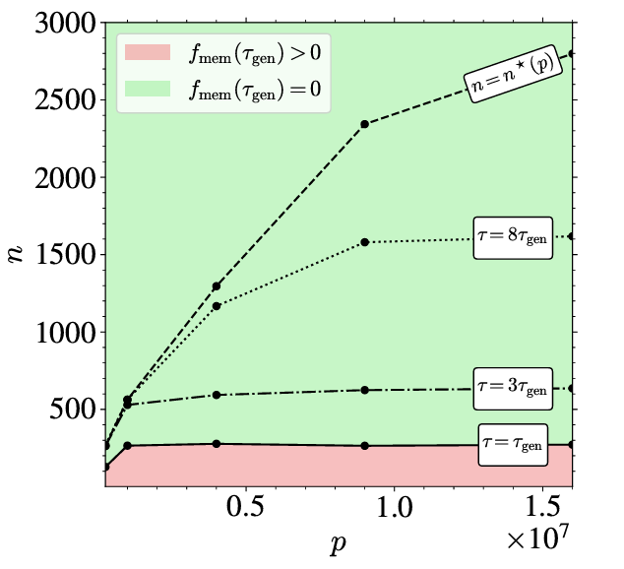
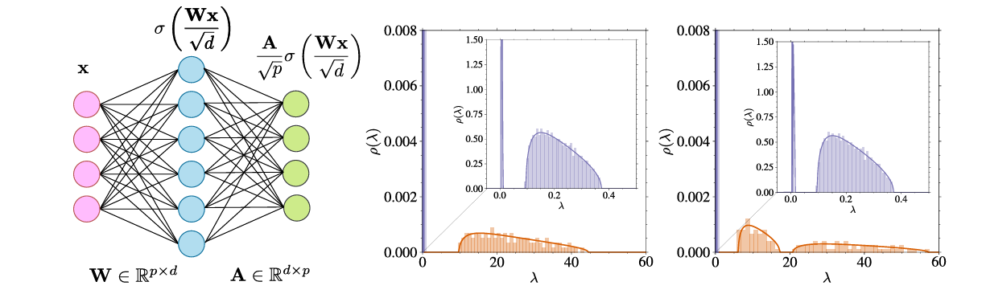

7. Empirical Validation on Real Data

7.1 Datasets
• CIFAR-10 (32×32, 50k) — Main experiments
• FFHQ (64×64, 70k) — Higher resolution validation
• CelebA (64×64, 200k) — Larger scale

7.2 Encoder Training
Train VAEs with varying bottleneck sizes: d_latent ∈ [32, 64, 128, 256, 512]
Architecture: Standard convolutional VAE. Loss: MSE reconstruction + KL divergence. Training: Full dataset (controlled encoder quality).
Verification: Compute reconstruction error on held-out set. If error too high → exclude (encoder bottleneck). If error comparable across d_latent → proceed.

7.3 Diffusion Training
For each frozen encoder: project data z = Encoder(x), train diffusion model (UNet) on z, vary n ∈ [500, 1k, 2k, 5k, 10k, 50k].
Track: Training loss over epochs, FID at checkpoints → identify τ_gen, memorization ratio at checkpoints → identify τ_mem.

8. Metrics
• FID: Generation quality (Inception features, lower = better)
• τ_gen: When quality emerges (first epoch where FID < threshold)
• Memorization ratio: Fraction of outputs matching training data (NN criterion: d₁ < d₂/3)
• τ_mem: When memorization begins (first epoch where mem_ratio > threshold)
• LID: Local dimensionality (FLIPD or Jacobian spectrum)
• Reconstruction error: Encoder quality (MSE on held-out data)
We could either take each point and do the forward diffusion process creating a gaussian distribution centered at each point to see if the point gets reproduced and if it is memorized according to one of the above metrics, or sample a random seed and get a resulting point. First one can probably do a more complete characterization of latent space, as the training points are the points of interest for memorization, but second one is more directly diffusion. (below are pros and cons of each, could alternatively just do both lol)

Protocol A: Training-Point-Centered Reconstruction
The procedure is to take each training point x₀, apply forward diffusion to obtain a noisy version x_t centered at that point, then run reverse diffusion to obtain a reconstruction x̂₀, and finally compare x̂₀ to the original x₀.
This approach asks: given that the model sees a noisy version of a specific training point, does it recover that exact point (memorization) or a plausible nearby sample (generalization)?
Advantages for our study:
Complete coverage of the training set. Every training point gets probed, allowing systematic characterization of which points are memorized and which generalize. This is crucial for correlating memorization with point-level properties like local intrinsic dimension, duplication status, or image complexity.
Direct attribution. When memorization is detected, we know exactly which training point is involved. This enables analysis of memorization as a function of where points sit in the latent space — are memorized points clustered? Do they have unusually low LID*? Are they near the boundary of the data manifold?
Efficiency for rare events. Memorization is often sparse — Carlini et al. found roughly 50 memorized images out of 175 million generations from Stable Diffusion. Random sampling would require enormous compute to detect these rare events. Training-point-centered probing directly tests the points most likely to be memorized.
Variable noise levels. By running the protocol at different noise levels t, we can characterize "memorization depth." A point memorized even from high noise (large t) is more strongly memorized than one only recovered from low noise (small t). This gives a continuous memorization score rather than a binary flag.
Connection to eigenvalue theory. The reconstruction view connects naturally to the eigenvalue framework. Memorization of a point corresponds to the model having learned the small eigenvalues (individual point details) in addition to the large eigenvalues (shared structure). Points with high reconstruction fidelity at large t are those whose individual signatures have been encoded.
Disadvantages:
Not the actual use case. Real deployment samples from pure noise, not from noisy training points. This protocol tests a reconstruction capability that users never invoke directly.
Potential conflation. Good reconstruction might reflect good denoising rather than memorization per se. A model that perfectly learns the score function would reconstruct well without necessarily "memorizing" in the problematic sense. The distinction between learning the distribution perfectly versus overfitting to specific points becomes blurred.
Biased toward training support. This protocol only probes the regions where training points exist. It says nothing about model behavior in regions between or outside training points — the generalization question in the truest sense.

Protocol B: Random Seed Generation
The procedure is to sample random noise z from the prior distribution, run the full reverse diffusion process to obtain a generated sample x̂₀, then compute nearest neighbor distances to the training set and flag as memorized if anomalously close.
This approach asks: when the model generates freely from noise, does it sometimes collapse onto exact training examples?
Advantages for our study:
Matches deployment. This is how diffusion models are actually used. Memorization detected this way represents a real privacy or copyright risk, not just a theoretical concern.
Unbiased sampling. Random seeds sample the full support of the learned distribution, including regions that might not correspond to any single training point. This tests whether the model has learned a continuous manifold or a collection of point masses.
Standard methodology. This is the protocol used by Carlini et al., Somepalli et al., and most memorization literature. Results are directly comparable to prior work.
Generation quality metrics. Since we're doing actual generation, we can simultaneously compute FID, precision, recall, and other quality metrics. This allows us to track the memorization-quality tradeoff as we vary latent dimension.
Disadvantages:
Sparse signal. Most random samples will not land near any training point, even for a memorizing model. Detecting memorization requires generating many samples and hoping some hit memorized modes. For rare memorization, this is statistically inefficient.
Attribution requires extra work. If we detect a memorized sample, identifying which training point it corresponds to requires a nearest neighbor search over the full training set. For large datasets, this is computationally expensive.
Incomplete picture. Even with millions of samples, we might miss training points that are memorized but have low probability under the learned distribution. A point could be perfectly memorized (zero reconstruction error) but rarely sampled because the model assigns it low density.

9. Expected Results

9.1 Main Finding
We expect τ_mem − τ_gen (the generalization window) to be maximized when d_latent ≈ d_intrinsic. Too small = information bottleneck. Too large = sparse embedding leading to earlier memorization.

9.2 Scaling Law
Hypothesized form: d*_latent = c · d_intrinsic^α · (n/n_0)^β
Where α ≈ 1 (linear in intrinsic dimension), β small or zero (weak dependence on n), and c ≈ 1 (optimal is close to intrinsic dimension).

9.3 Case 2 Findings
For jointly trained encoder + diffusion, we predict that for small n, encoder quality is the bottleneck, not diffusion memorization. There should be a "safe zone" where both encoder works and diffusion generalizes.

10. Contributions
1. Theoretical: First analysis of how d_latent affects τ_gen and τ_mem, extending Bonnaire's framework
2. Empirical: Systematic measurement of optimal latent dimension across dataset sizes
3. Practical: Guidelines for choosing d_latent given n and estimated d_intrinsic
4. Unifying: Connect dynamics view (Bonnaire) with geometric view (Ross/Achilli) and scaling view (Mei) through latent space lens

11. Open Questions
5. Does conditioning interact with d_latent? CFG reduces effective LID — does smaller d_latent amplify this?
6. Is d* architecture-dependent? UNet vs Transformer may have different optima
7. How to estimate d_intrinsic in practice? Need practical method to guide d_latent choice for new domains
8. Does the encoder type matter? VAE vs AE vs VQ-VAE may have different latent structure
9. How does memorization-optimal d_latent relate to Mei's compute-optimal model size? Are they aligned or in tension?
10. Is it data repetition or n--dependent (we could test this by like just duplicating 10k images into 60k and comparing it to 60k unique)
11. How do different optimizers work (we will probably use SGD for the main paper and supplementary results can use adam or wtvr. Have good code quality xd to allow for easier replicating when using other optimizers)
[this needs to be continued[

Literature Review: Memorization in Diffusion Models

Overview
Five key papers [for now..]:
• Bonnaire et al. — Why diffusion models don't memorize (theoretical, eigenvalue dynamics) https://arxiv.org/pdf/2505.17638
• Gu et al. — What factors cause memorization (empirical, systematic ablations) https://arxiv.org/pdf/2310.02664
• Ross et al. — Geometric detection of memorization (LID-based framework, MMH) https://arxiv.org/pdf/2411.00113v1
• Achilli et al. — How dimensions collapse during memorization (statistical physics, Jacobian spectrum) https://arxiv.org/pdf/2410.08727v1
• Mei et al. — Scaling laws for latent diffusion (empirical, compute-optimal scaling) https://arxiv.org/pdf/2404.01367v1

1. Bonnaire et al. (NeurIPS 2025 Best Paper)
"Why Diffusion Models Don't Memorize: The Role of Implicit Dynamical Regularization in Training"

Main Points
(1) The paradox: Closed-form optimal score only outputs training data, yet real models generalize.
(2) Two timescales emerge from training dynamics: τ_gen = O(1) when generation quality emerges; τ_mem = O(n) when memorization begins.
(3) Mechanism: Eigenvalue spectrum of feature correlation matrix U splits into two bulks — ρ₂ (large eigenvalues, learned fast, general structure) and ρ₁ (small eigenvalues, learned slow, individual points).
(4) Key result: Gap between bulks scales as ψ_n = n/d. More data → bigger gap → wider safe training window.
(5) Toy model: Random Features Neural Network (RFNN) where only output weights A are learned, W frozen. Makes math tractable via random matrix theory.

Relevance to Our Project
Directly foundational. Their framework gives us: the quantity to optimize (τ_mem − τ_gen), the mechanism (eigenvalue gap determines timing), and the scaling (gap ∝ n/d). Our extension: Replace d with d_latent. Predict gap ∝ n/d_latent.

Strengths
• Rigorous theoretical derivation
• Clear mechanism (not just correlation)
• Validated on real networks
• Best paper award = community endorsement

Weaknesses / Limitations
• Toy model is very simple (1 learned layer, simple data)
• High-dimensional limit (d, p, n → ∞) may not hold for realistic scales
• Doesn't address latent space / compression
• ψ_p >> 1 assumption breaks for large d_latent with tractable p

Opinion
Fuck chatgpt’s opinion my opinion is that their toy model and derivation of the eigenvalue distribution is relevant. Its best if we can rpodcue the two groups of eigne values as that’ll basically be a very solid paper in of itself, and would easily justify the empirical work we do. But chatgpt’s opinion is below.
This is the most principled paper of the bunch. The eigenvalue analysis actually explains why things happen, not just that they happen. The limitation is tractability — extending their analysis to realistic latent dimensions is hard. We'll use their framework conceptually but may need to rely on empirical validation rather than full derivation.

2. Gu et al. (TMLR 2025)
"On Memorization in Diffusion Models"

Main Points
(6) EMM (Effective Model Memorization): Maximum dataset size at which model still memorizes like the theoretical optimum.
(7) Systematic ablations across three axes: Data distribution (dimension, diversity), model configuration (width, depth, skip connections, time embedding), and training procedure (batch size, weight decay, EMA).
(8) Key findings: Smaller dataset → more memorization; lower resolution → higher EMM; wider models → higher EMM; depth has non-monotonic effect (sweet spot ~6 blocks); high-resolution skip connections matter most.
(9) Surprising result: Random uninformative labels trigger massive memorization (0% → 65% on CIFAR-10 with unique labels).
(10) Memorization criterion: d₁ < d₂/3 (nearest neighbor ratio with threshold 1/3).

Relevance to Our Project
Methodological template. They show how to define a memorization metric (EMM), systematically vary factors, and present results across (factor, dataset_size) grid. Gap they leave: They vary image resolution but NOT latent dimension. Our project fills this gap.

Strengths
• Comprehensive — covers many factors
• Reproducible — clear experimental protocol
• Practical — results directly inform model design

Weaknesses / Limitations
• No theory for why factors matter
• Memorization criterion (1/3 threshold) is arbitrary
• Resolution ≠ latent dimension (they don't use encoders)
• Can't distinguish "sparse region" from "memorization" with NN ratio

Opinion
This is most likely what our paper would look like btw, i mean its like decent but its not very principled. It also explores the idea of dimensionality/width/depth, but not specifically latent spaces. This might relate to effective dimensionality (conditioning creates sparser subspaces). There are a few sketchy aspects such as 1/3 threshold for memorization detection is sketchy imo. A good exploration is like seeing how labels affect density/dimensionality of the points, possibly giving a reason for why CFG leads to more memorization?
Good empirical paper, but feels like "we tried a bunch of stuff and reported what happened." No unifying principle. The random labels finding is genuinely surprising and underexplored — why does conditioning cause memorization even when uninformative??

3. Ross et al. (MMH Paper)
"A Geometric Framework for Understanding Memorization in Generative Models"

Main Points
(11) Manifold Memorization Hypothesis (MMH): Memorization occurs when LID_θ(x) is "too low."
(12) Two types of memorization: OD-Mem (Overfitting-Driven) where LID_θ(x) < LID*(x) — model failure; DD-Mem (Data-Driven) where LID_θ(x) = LID*(x) but both low — data problem.
(13) LID (Local Intrinsic Dimension): How many degrees of freedom the model has at point x. LID = 0 is exact memorization; LID = d_intrinsic is full generalization.
(14) CFG connection: Large CFG vector norm → large score norm → low LID → memorization. Provides cheap detection without comparing to training set.
(15) Mitigation: Token attribution to find which prompt words cause memorization, then rephrase.

Relevance to Our Project
Provides the geometric interpretation. Memorization = dimensionality collapse. Latent dimension affects how much "room" the model has. If d_latent > d_intrinsic, you have "wasted dimensions" that might collapse first during memorization.

Strengths
• Unifying framework (explains verbatim, template, reconstructive memorization)
• Works without access to training data (unconditional LID detection)
• Actionable (token attribution for mitigation)

Weaknesses / Limitations
• FLIPD can produce negative values (artifact)
• Doesn't explain when memorization happens during training
• Confounded by image complexity (simple images have low LID but aren't memorized)

Opinion
Take a look at the DD v OD memorization distinction. I think its best if we detect focus on detecting DD instead. The point is is that the data is learnable (not too sparse) but the latent dimensionality makes it sparse. So technically if we consider the post latent space applied dataset we’re detecting DD memorization. As such LID* v LID(theta) comparison is probably relevant.
The OD-Mem vs DD-Mem distinction is genuinely useful — it tells you whether to fix your model or your data. But the paper is more about detection than understanding. They can tell you "this point is memorized" but not "this is why it happened during training." LID and Jacobian spectrum are literally the same measurement. The field has multiple names for one thing.

4. Achilli et al.
"Losing Dimensions: Geometric Memorization in Generative Diffusion"

Main Points
(16) Geometric memorization: Dimensions are lost gradually, not all at once. Different tangent subspaces collapse at different critical times.
(17) Counterintuitive finding: High-variance directions collapse FIRST. You'd think high variance = more spread = harder to memorize. Actually, high variance directions emerge early AND collapse early.
(18) Analysis via Jacobian spectrum: Small singular values = tangent to manifold (free directions); large singular values = orthogonal to manifold (constrained). Gap closing = dimension collapsing = memorization.
(19) Critical time formula: t_c(x) depends on variance along direction x. Higher variance → larger t_c → memorization earlier.
(20) Statistical physics framing: Memorization as "condensation" in Random Energy Model.

Relevance to Our Project
Bridges Bonnaire and Ross. Bonnaire: eigenvalues determine timing. Ross: LID measures memorization. Achilli: eigenvalues of Jacobian = LID, and they collapse selectively. For latent space: if d_latent > d_intrinsic, the "extra" dimensions are low-variance. Achilli predicts these should be more robust to memorization, but meaningful high-variance directions might collapse first.

Strengths
• Full geometric picture (not just scalar LID, but which directions)
• Explains selective/partial memorization
• Theory matches experiments qualitatively

Weaknesses / Limitations
• Analysis is for empirical score (finite samples), not trained networks
• Linear Gaussian data assumption for tractability
• Jacobian computation is expensive (d forward passes)

Opinion
This is the idea for maybe measuring density? Though latent spaces should be principled but may not specifically increase density in a principled way, so it might be a weird to measure. Gotta think of a way to measure “dneisyt” of latent spaces. Jacobian measure is interesting but may not be relevant. Uhhh idk we can take some intuition here to write our intro i guess and conclusion.
This paper is the geometric version of Bonnaire. Same phenomenon (eigenvalue structure determines memorization), different lens (Jacobian of score vs feature correlation matrix). The high-variance-collapses-first finding is genuinely surprising and important — prominent features of the data are most vulnerable. Computational cost is the main barrier for realistic d_latent.

5. Mei et al.
"Bigger is not Always Better: Scaling Properties of Latent Diffusion Models"

Main Points
(21) First systematic scaling laws for LDMs: Loss follows power-law relationship with compute budget, analogous to scaling laws in language models.
(22) Core finding: Under fixed inference budget, smaller models often outperform larger ones. "Bigger is better" only holds when inference cost is ignored.
(23) Compute-optimal tradeoffs: For a given compute budget, there exist optimal combinations of model size, training data size, and training steps.
(24) Latent space matters: Compression ratio affects compute-quality tradeoffs.
(25) Practical implications: Guidelines for choosing model size given deployment constraints.

Relevance to Our Project
Directly relevant to latent dimension question. If smaller models can outperform larger ones under inference constraints, then smaller latent dimensions might also have a "sweet spot" — not just for memorization, but for overall efficiency. Justifies why optimizing d_latent matters practically.

Strengths
• Rigorous scaling law methodology (Chinchilla-style analysis)
• Practical focus (inference budget matters in deployment)
• Directly addresses latent diffusion

Weaknesses / Limitations
• Doesn't directly address memorization (focuses on loss/quality)
• Scaling laws are empirical fits, not derived from theory
• Latent dimension is confounded with other architectural choices

Opinion
Basically the motivation for the project – not rly that relevant technical wise, maybe take a look at their architecture decisions if u got time but the architecture decisions of the other papers are a lto more relevant.
This paper provides the practical/engineering perspective the other papers lack. Bonnaire, Ross, and Achilli are about understanding memorization theoretically. Gu is about empirical factors. Mei is about "what should I actually deploy?" The "bigger is not always better" finding supports our hypothesis that there's an optimal d_latent. Limitation: They don't connect scaling to memorization. We need to bridge their scaling perspective with the memorization perspective.

Cross-Paper Synthesis

What They Agree On
• More data → less memorization (all papers)
• Model capacity affects memorization (Bonnaire, Gu, Mei)
• Dimensionality matters (all papers)
• Memorization is gradual (Bonnaire, Gu, Ross, Achilli)

Complementary Contributions
Bonnaire provides the MECHANISM (eigenvalue separation) → Gu maps the FACTORS (what shifts the boundary) → Ross enables DETECTION (LID collapse) → Achilli gives the full SPECTRUM (which directions collapse) → Mei addresses DEPLOYMENT (practical tradeoffs).

What's Missing (Our Contribution)
None of them fully study latent dimension's effect on memorization:
• Bonnaire analyzes d (ambient dimension) but not d_latent
• Gu varies resolution but not latent space
• Ross measures LID but doesn't connect to encoder design
• Achilli does full geometric analysis but no encoder
• Mei studies latent scaling but not memorization specifically
Our project bridges this gap: How does the choice of d_latent affect τ_gen, τ_mem, and the eigenvalue/LID structure?

